HOME GROWN SCHOOL FEEDING PROGRAMME

When the outbreak of COVID-19 intensified, the Government of Zimbabwe had to close schools­­ and this led to the suspension of school feeding programmes. Due to these school closures, **2,716,363** primary school children from schools who were benefitting from the school feeding programme were affected. For many, hungry children, a school meal may be their main meal of the day – without it, they lose the protection of vital vitamins and micronutrients. For poor families with several children in school, the loss of the school meal increases food supply pressure at home.

With the availability of funds, Ministry of Primary and Secondary Education (MoPSE) with the support of UNICEF is procuring cooking serving utensils to support 100 selected schools in Gokwe North, Makoni and Masvingo. School feeding utensils for the 100 schools supported by UNICEF are as:

|  |  |  |
| --- | --- | --- |
| **Category of utensils** | **Number of Schools** | **Quantity** |
| Plastic Plates | 100 | 31,600 |
| Three legged pots | 100 | 100 |
| Cups | 100 | 31,600 |

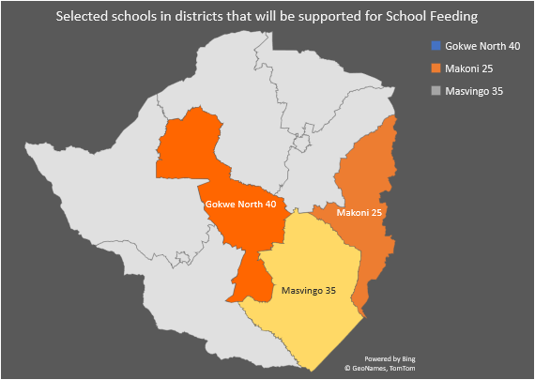

**Food Safety Standards**

MoPSE with support from UNICEF has been working to develop the food safety standards. These food safety standards are aimed at standardising the implementation, monitoring, evaluation, and quality assurance of the Home-Grown School feeding programme.  Currently the draft food safety standards booklet is being finalised by the Curriculum Development and Technical Services Department of MoPSE.

**School Feeding Strategy and Handbook for Food Handlers**

MoPSE is also in the process of finalising the School Feeding Strategy and the Handbook for Food Handlers. The school feeding strategy will target P3 and satellite school pupils deprived of school meals during and after the COVID-19 lockdown period, without compromising on the social distancing guidelines provided by the Ministry of Health and the World Health Organisation. The Handbook for Food Handlers and the School Feeding Strategy will support the Education Cluster partners in the implementation of the School Feeding Programme to ensure the safety of food handlers, learners, and teachers.

.